**Validation check for** [**https://lab3.jordanwentland.com**](https://lab3.jordanwentland.com)

Validation Check CSS:

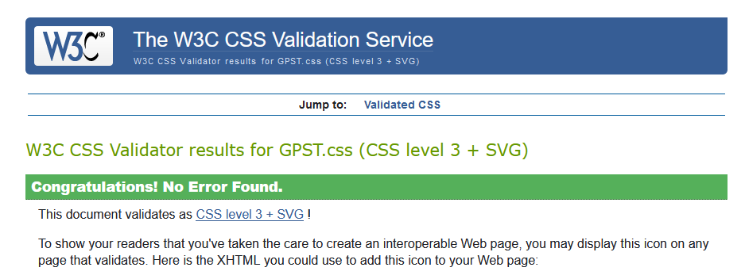

Validation Check HTML (index)

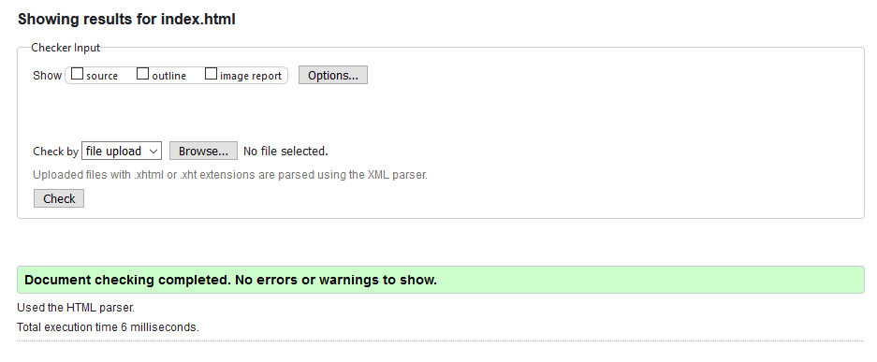

Validation Check HTML (board)

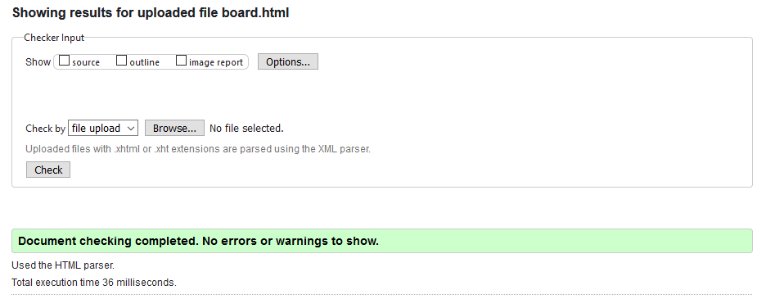

Validation Check HTML (training)

